



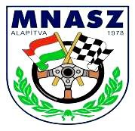



**1st Bulletin**

**Total International RallycrossParade**

**FIA RALLYCROSS CEZ ZONE CHAMPIONSHIP ROUND VI.**

**MNASZ HUNGARIAN NATIONAL OPEN RALLYCROSS CHAMPIONSHIP**

**ROUND VI.**

**RALLYCROSS NATIONAL AMATEUR CHAMPIONSHIP ROUND I.**

**Venue: Máriapócs,RabócsiRing**

**Date: 06.10.2017.**

**(Friday, Saturday, Sunday)**

# Time Schedule:

**06.10.2017 Friday**

15: 00 – 15: 45 Administrative checking Amateur

15: 10 -16: 00 Technical checking Amateur

15: 00 – 15: 45 Technical checking RNOB+CEZ

16: 00 – 20: 00 Administrative checking RNOB+CEZ

16: 15 – 20: 30 Scrutineering RNOB+CEZ

**RNOB+CEZ – Administrative Checking:**

16: 00 – 16: 25 Administrative checking Junior Kupa 25’

16: 25 – 16: 45 Administrative checking Suzuki Division 20’

16: 45 – 17: 20 Administrative checking Astra Division 35’

17: 20 – 18: 00 Administrative checking Magyar Kupa 40’

18: 00 – 18: 15 Administrative checking SuperTouringCars -1600 15’

18: 15 – 18: 35 Administrative checking SuperTouringCars -2000 20’

18: 35 – 19: 00 Administrative checking SuperTouringCars +2000 25’

19: 00 – 19: 20 Administrative checking Super1600 20’

19: 20 – 20: 00 Administrative checking SuperCars 40’

**RNOB+CEZ – Scrutineering:**

16: 15 – 16: 40 Scrutineering Junior Kupa 25’

16: 40 – 17: 05 Scrutineering Suzuki Division 25’

17: 05 – 17: 45 Scrutineering Astra Division 40’

17: 45 – 18: 25 Scrutineering Magyar Kupa 40’

18: 25 – 18: 40 Scrutineering SuperTouringCars -1600 15’

18: 40 – 19: 00 Scrutineering SuperTouringCars -2000 20’

19: 00 – 19: 30 Scrutineering SuperTouringCars +2000 30’

19: 30 – 19: 50 Scrutineering Super1600 20’

19: 50 – 20: 30 Scrutineering SuperCars 40’

**07.10.2017 Saturday**

08: 30 I. Steward Meeting

09: 00 – 09: 25 I Free Practice Amateur

**09: 25 – 10: 35 I. Free Practice RNOB+CEZ**

10: 35 Publish I. Qualifying Heat Draw

10: 35 – 10: 55 Repair of the Track

10: 55 – 11: 20 II. Free Practice Amateur

**11: 20 – 12: 30 II. Free Practice RNOB+CEZ**

12: 30 – 12: 50 Repair of the Track

12: 50 – 13: 30 I. Qualifying Heat Amateur

**13: 30 – 15: 40 I. Qualifying Heat RNOB+CEZ**

**15: 40 – 16: 20 II. Qualifying Heat RNOB (JuniorKupa, Swift Div., Astra Div.)**

16: 20 – 17: 00 II. Qualifying Heat Amateur

**08.10.2017 Sunday**

**08: 45 – 09: 50 II. Qualifying Heat RNOB (MagyarKupa)+CEZ**

09: 50 – 10: 10 Repair of the Track

10: 10 – 10: 50 III. Qualifying Heat Amateur

**10: 50 – 12: 50 III. Qualifying Heat RNOB+CEZ**

after III. Qualifying Heat II. Steward Meeting

12: 50 – 13: 30 Repair of the Track

**13: 30– 14: 35 SemiFinals RNOB+CEZ**

14: 35 – 14: 50 SemiFinals Amateur

14: 50 – 15: 00 Repair of the Track (10min)

**15: 00 – 16: 00 Finals RNOB+CEZ**

after the Finals III**.** Steward Meeting

16: 00 – 16: 20 Finals Amateur

20 mins after the Finals prize-giving ceremony at the podium!

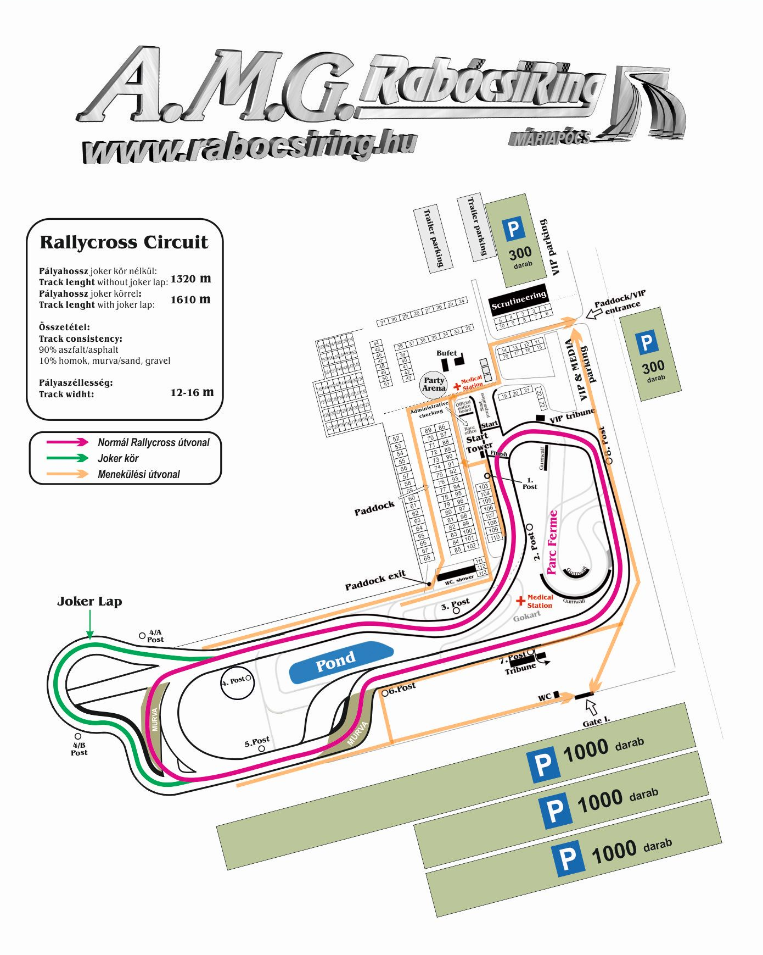

Appoved by MNASZ Off Road Commission.

Máriapócs, 21.09.2017 **OrganizingCommittee**